Usage Statistics for snydersstoughton.com
Summary Period: Last 12 Months
Generated 30-Aug-2010 00:29 EDT

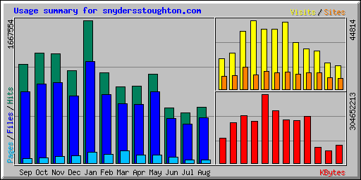
Summary by Month
Month | Daily Avg |  |  |  | Monthly Totals
Month | Hits | Files | Pages | Visits | Sites | KBytes | Visits | Pages | Files | Hits
Aug 2010 | 21635 | 17651 | 1156 | 512 | 6999 | 79101282 | 15389 | 34693 | 529555 | 649054
Jul 2010 | 18973 | 14679 | 1129 | 550 | 7342 | 54372258 | 17077 | 35003 | 455066 | 588184
Jun 2010 | 21509 | 17478 | 2306 | 827 | 10669 | 71419993 | 24823 | 69208 | 524350 | 645276
May 2010 | 33573 | 26804 | 3140 | 845 | 10963 | 206888883 | 26200 | 97357 | 830953 | 1040789
Apr 2010 | 30101 | 22836 | 3103 | 1009 | 10034 | 188036572 | 30284 | 93117 | 685095 | 903047
Mar 2010 | 28733 | 22273 | 4552 | 1413 | 11062 | 189934460 | 43810 | 141126 | 690479 | 890729
Feb 2010 | 37695 | 28527 | 3718 | 1396 | 10837 | 231937051 | 39108 | 104125 | 798779 | 1055470
Jan 2010 | 53792 | 38409 | 4063 | 1260 | 11531 | 304652213 | 39079 | 125981 | 1190687 | 1667554
Dec 2009 | 34908 | 25328 | 2791 | 1445 | 9244 | 183659700 | 44814 | 86547 | 785196 | 1082160
Nov 2009 | 42651 | 31474 | 2510 | 1258 | 14602 | 208497587 | 37747 | 75300 | 944222 | 1279533
Oct 2009 | 41460 | 29712 | 1894 | 752 | 9102 | 178337175 | 23324 | 58744 | 921087 | 1285276
Sep 2009 | 38445 | 27850 | 1829 | 655 | 8529 | 111814873 | 19673 | 54891 | 835512 | 1153367
Totals |  |  |  |  |  | 2008652047 | 361328 | 976092 | 9190981 | 12240439

Generated by Webalizer Version 2.01

